# PROJECT PROPOSAL REPORT

## Introduction

Since the invention of cameras photography has existed as an artistic field and has been constantly growing with time especially due to the invention of modern digital cameras and evolution of technology in optics which has allowed people to have high quality cameras within their mobile phones, This has led to the increase in professional photographers across the world who are unemployed and cannot afford some of the equipment used in photography.

## Business explanation

It is estimated that there is a population of 75.3 million professional photographers who invest a lot of effort to ensure they capture the best photos and record the most artistic videos. Since photography is a profession I have decided to create a platform in which photographers across the world can sell their copyrighted photographs and receive income each and every time their photos are downloaded or commercially used.

This site will also hire photography equipment such high pixel cameras, stands and lighting equipment to photographers who don’t have the ability to buy these expensive equipment

Photographers will have administrative accounts in which they will have the ability to login and upload copyrighted photos which can then be viewed by the public. The public will view these photos as watermarked and the watermark will be removed once they have paid for photo.

## Wireframes

The wireframes for this website was designed by figma which is a web application available at [www.figma.com](http://www.figma.com/)

### Landing page

The landing page wireframe link is <https://www.figma.com/file/J7VC8GwwUwIrqrPTg3E1kH/photography?node-id=0%3A1>

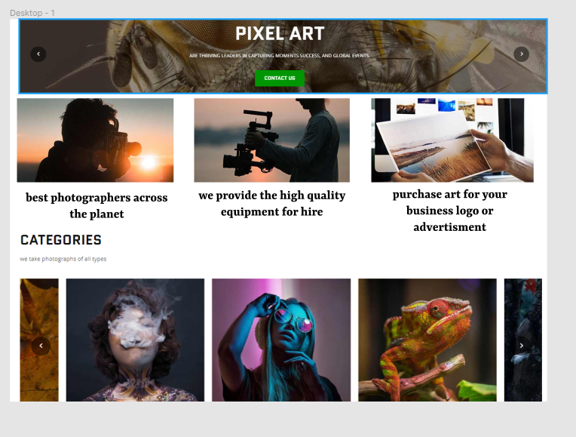

The landing page will have a colorful design with lots of high quality art from our photographers/trusted sources.

The mobile version of the landing page is available at <https://www.figma.com/file/J7VC8GwwUwIrqrPTg3E1kH/photography?node-id=3%3A27>

The page is expected to be responsive when viewed through devices with small screens.



### Contact page

The link to the contact page wireframe is available at <https://www.figma.com/file/J7VC8GwwUwIrqrPTg3E1kH/photography?node-id=3%3A5>

The contact page will be used by the general public to write enquiry messages to our company.



## Feature and content explanation

The website will have a landing page in which customers and the general public will get to see all the features and services provided our company. These page will include some of the best-selling artwork from our registered photographers.

There will be a sign up page in which professional photographers can create accounts for selling their art. A registration fee will be required so as to minimize the amount of idle accounts created and to ensure that the photographer has set up the necessary payment plans.

Photographers will have the ability to monitor the sales progress of their art and receive monthly income depending on how their art sold.

## Company revenue

The company will make its revenue by a taxing every sale made from a piece of art (preferably 5% tax). This tax will be kept low so as to encourage more photographers to sell their art with us. Revenue will also be incurred by the registration fees collected during account creation.

## References

Coursetro (2019, November 21), Figma Tutorial - An Introduction to a Very Impressive UI Design & Prototyping Tool [accessed from] <<https://coursetro.com/posts/design/153/Figma-Tutorial---An-Introduction-to-a-Very-> Impressive-UI-Design-&-Prototyping-Tool>

hackio (2019, November 21), Figma Tutorials and Courses

[accessed from] <https://hackr.io/tutorials/learn-figma>